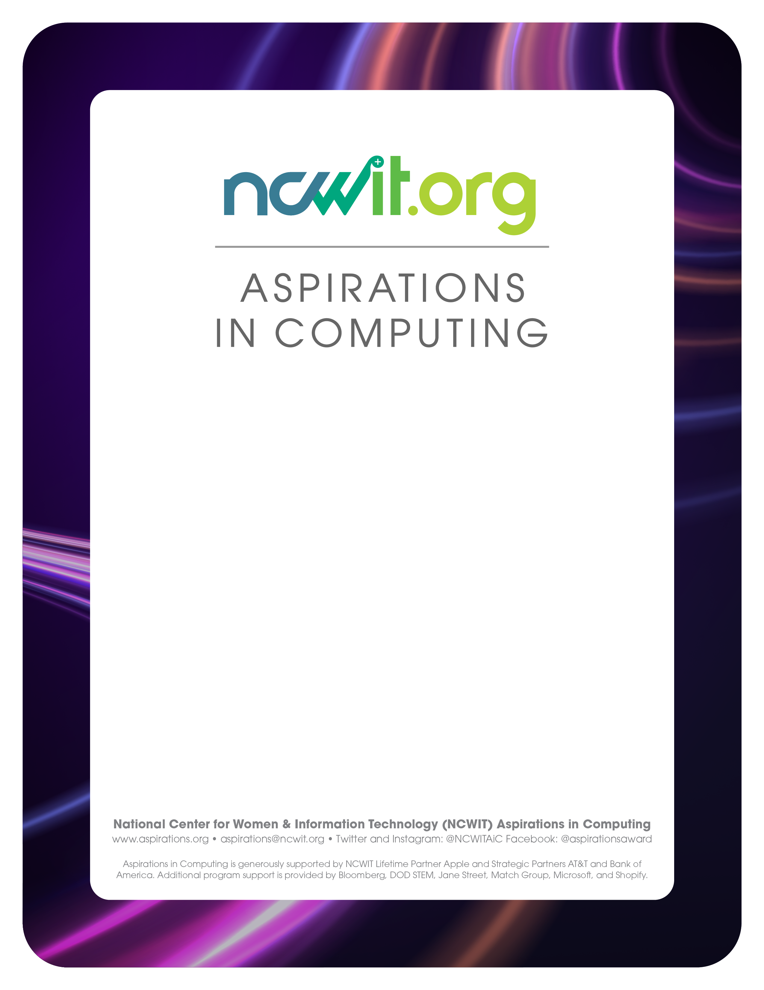

**[NAME] AFFILIATE**

AWARD CELEBRATION

[Day], [Month], [Year]

[Location]

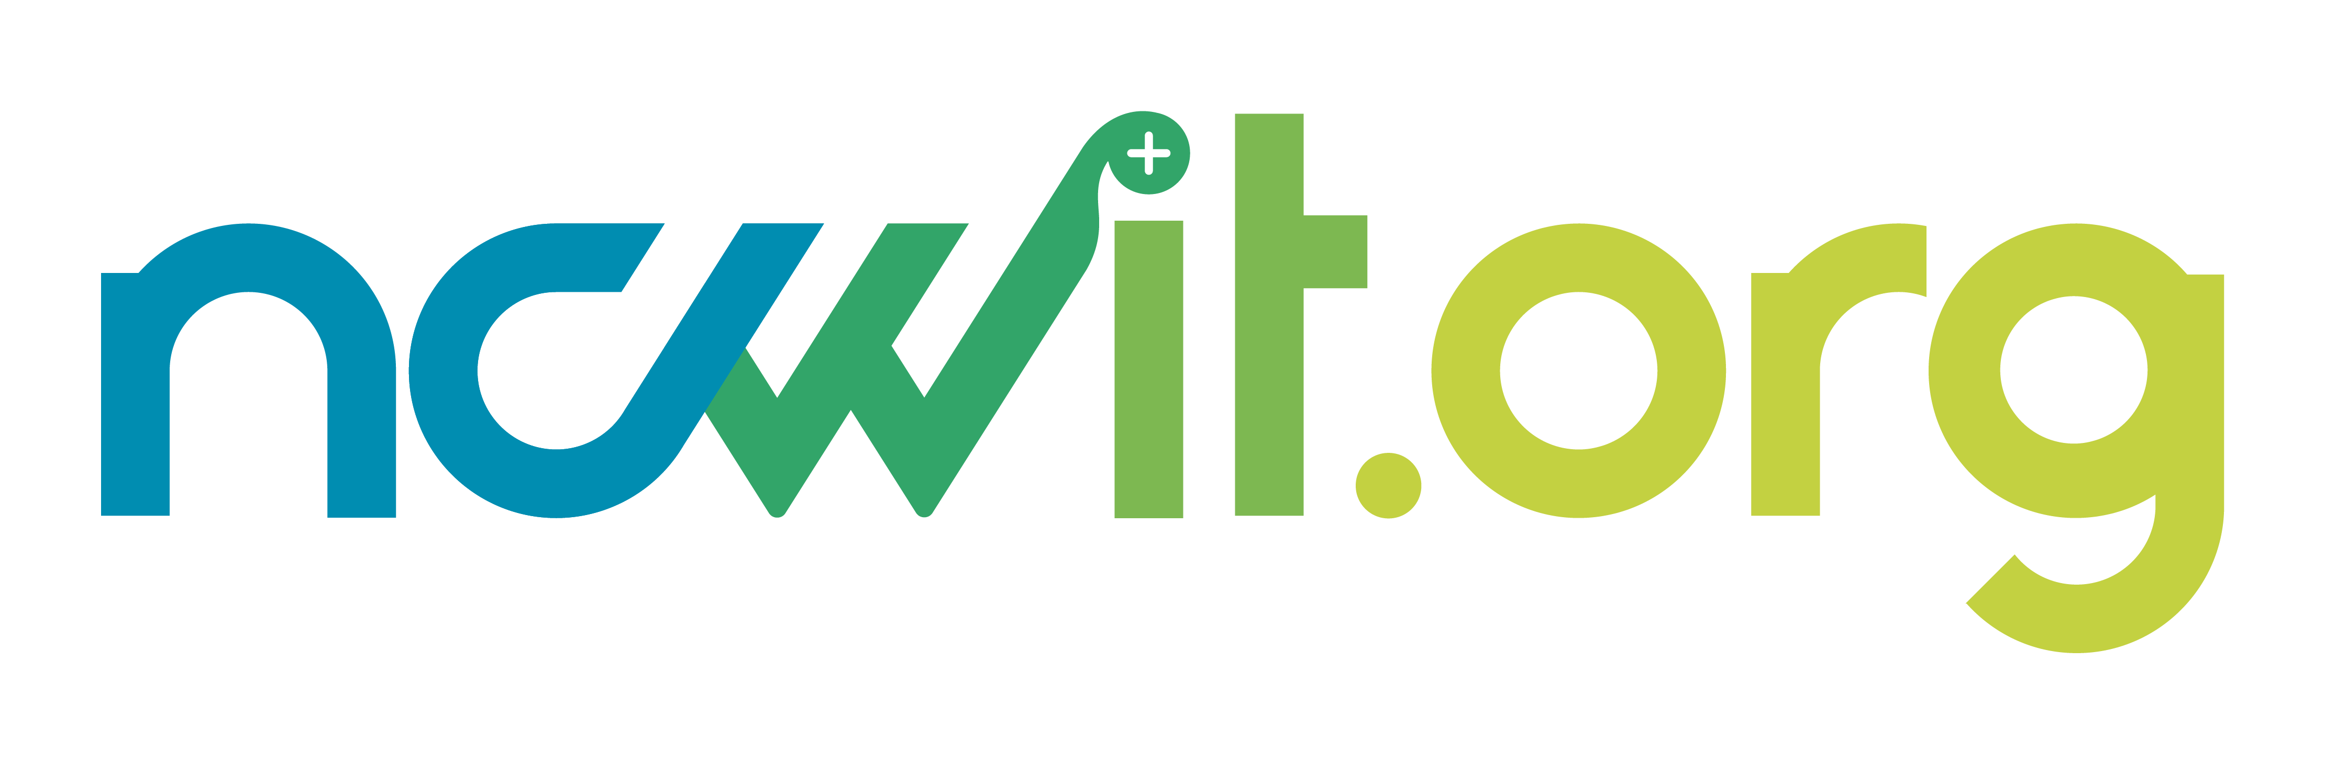**ABOUT THE NATIONAL CENTER FOR   
WOMEN & INFORMATION TECHNOLOGY (NCWIT)**

The National Center for Women & Information Technology (NCWIT) is the farthest-reaching network of change leaders focused on advancing innovation by correcting underrepresentation in computing. NCWIT convenes, equips, and unifies nearly 1,600 change leader organizations nationwide to increase the influential and meaningful participation of girls and women –– at the intersections of race/ethnicity, class, age, gender identity, sexual orientation, disability status, and other historically marginalized identities –– in the field of computing, particularly in terms of innovation and development. Find out more at [www.ncwit.org](http://www.ncwit.org).



**ABOUT NCWIT ASPIRATIONS IN COMPUTING (AiC)**

NCWIT Aspirations in Computing (AiC) works to close the gender gap in computing and technology through programs that build persistence, computing identity, and confidence in high school and college aged women, non-binary, and genderqueer people. AiC identifies and recognizes potential, creates a sense of belonging, and offers meaningful opportunities to build skills, connect, and to support individuals.

AiC reaches all 50 states, the District of Columbia, Puerto Rico, Guam, the U.S. Virgin Islands, U.S. military bases overseas, and Canada.

**[NAME] AFFILIATE EVENT AGENDA**

|  |  |  |
| --- | --- | --- |
| **TIME** | **EVENT** | **LOCATION** |
| **[H:MM] [xM]** | **[Title]**  **[**Presenter(s)’ Name and Title]  **[***Description***]** | **[Room]** |
| **[H:MM] [xM]** | **[Title]**  **[**Presenter(s)’ Name and Title]  **[***Description***]** | **[Room]** |
| **[H:MM] [xM]** | **[Title]**  **[**Presenter(s)’ Name and Title]  **[***Description***]** | **[Room]** |
| **[H:MM] [xM]** | **[Title]**  **[**Presenter(s)’ Name and Title]  **[***Description***]** | **[Room]** |
| **[H:MM] [xM]** | **[Title]**  **[**Presenter(s)’ Name and Title]  **[***Description***]** | **[Room]** |
| **[H:MM] [xM]** | **[Title]**  **[**Presenter(s)’ Name and Title]  **[***Description***]** | **[Room]** |
| **[H:MM] [xM]** | **[Title]**  **[**Presenter(s)’ Name and Title]  **[***Description***]** | **[Room]** |
| **[H:MM] [xM]** | **[Title]**  **[**Presenter(s)’ Name and Title]  **[***Description***]** | **[Room]** |
| **[H:MM] [xM]** | **[Title]**  **[**Presenter(s)’ Name and Title]  **[***Description***]** | **[Room]** |
| **[H:MM] [xM]** | **[Title]**  **[**Presenter(s)’ Name and Title]  **[***Description***]** | **[Room]** |

**[NAME] AFFILIATE EVENT COMMITTEE**

|  |
| --- |
| [Committee Member’s Name and Title] |
| [Committee Member’s Name and Title] |
| [Committee Member’s Name and Title] |
| [Committee Member’s Name and Title] |
| [Committee Member’s Name and Title] |
| [Committee Member’s Name and Title] |
| [Committee Member’s Name and Title] |
| [Committee Member’s Name and Title] |
| [Committee Member’s Name and Title] |
| [Committee Member’s Name and Title] |

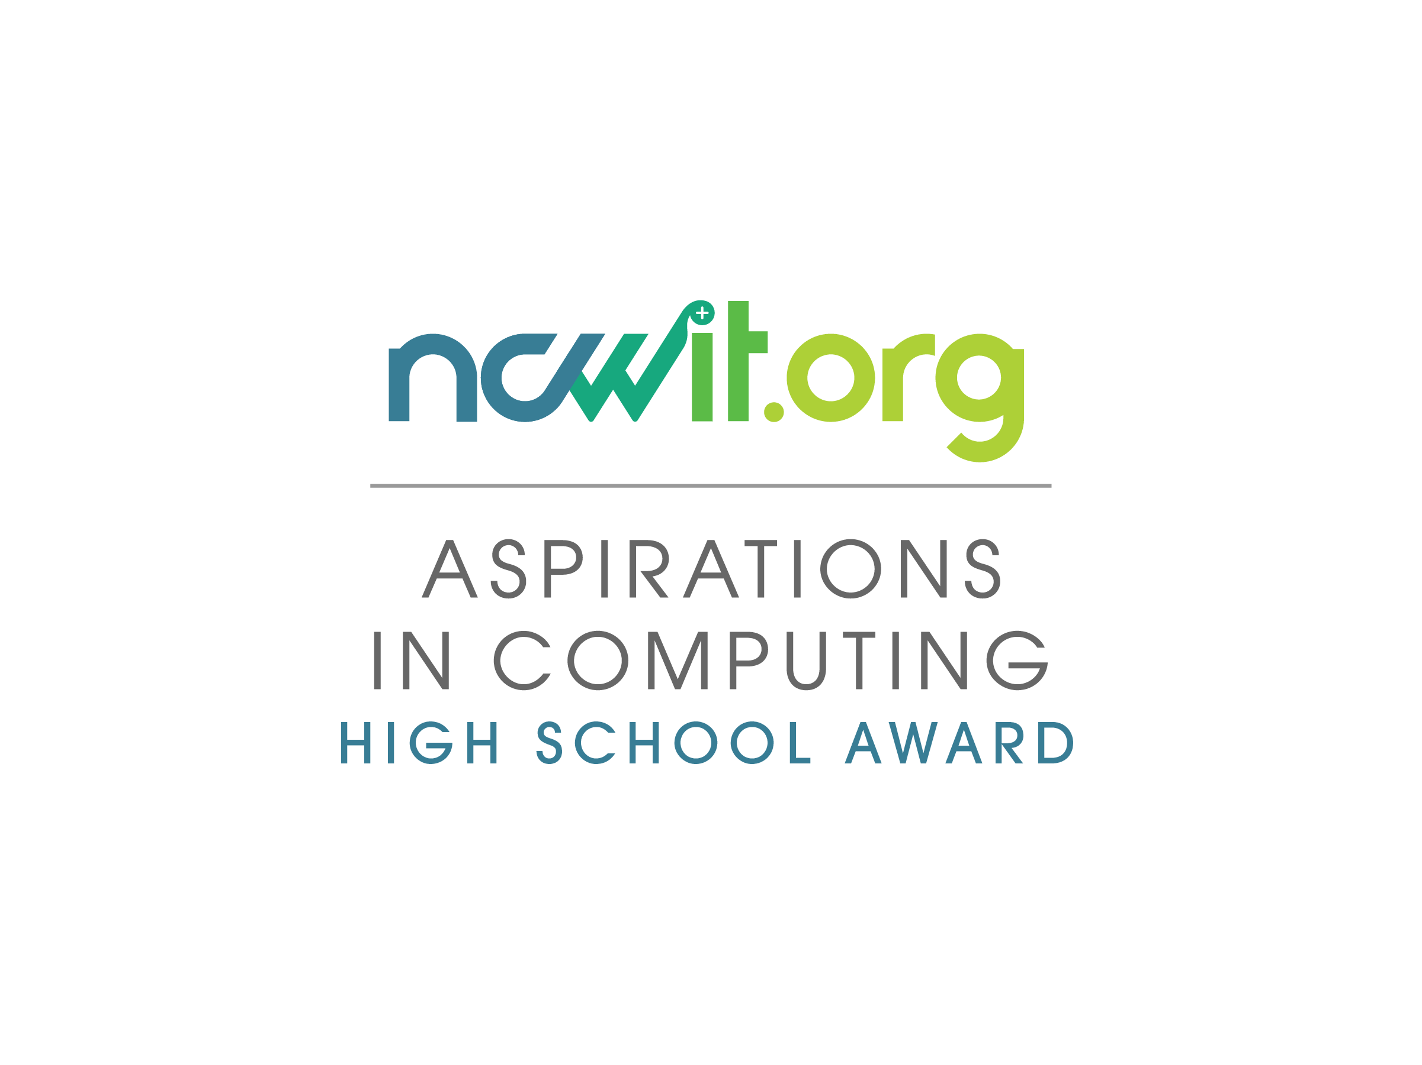

The NCWIT Aspirations in Computing High School Award honors 9th-12th grade women, genderqueer, and non-binary students for their computing-related achievements and interests and encourages them to pursue their passions. These award recipients are then inducted into the AiC Community — a phenomenal network of 25,000 technical women, genderqueer, and non-binary individuals who receive many exclusive benefits. Through Award Recognitions and the Community, AiC reaches all 50 states, the District of Columbia, Puerto Rico, Guam, the U.S. Virgin Islands, all U.S. military bases overseas, and Canada. Find out more at www.aspirations.org/recognitions/AiCAward.

**[YEAR] [NAME] AFFILIATE AWARD WINNERS**

|  |  |
| --- | --- |
|  | **YUKTI ABROL**  The Bronx High School of Science,  Bronx, NY  Class of 2015  Yukti has been interested in science and technology from a young age and over the last three years she has been developing her knowledge of computer science and programming skills. These skills have enabled Yukti to achieve her greatest technical accomplishment to date – the joint development of a 2D, culinary-based, computer game called Nom Quest and it doesn’t stop there: she is currently looking to further develop her aptitude and depth of programming knowledge with the development of a 3D pinball game. An analyst by nature Yukti’s plans for matriculation in the WISE program at Stony Brook University will hopefully launch her into the world of biomedical engineering and computer science. |

|  |  |
| --- | --- |
|  | **[NAME]**  [School]  [City/Town]  [Class]  [Biography] |

|  |  |
| --- | --- |
|  | **[NAME]**  [School]  [City/Town]  [Class]  [Biography] |

|  |  |
| --- | --- |
|  | **[NAME]**  [School]  [City/Town]  [Class]  [Biography] |

|  |  |
| --- | --- |
|  | **[NAME]**  [School]  [City/Town]  [Class]  [Biography] |

**[YEAR] [NAME] AFFILIATE AWARD HONORABLE MENTIONS**

|  |  |
| --- | --- |
|  | **YUKTI ABROL**  The Bronx High School of Science,  Bronx, NY  Class of 2019  Yukti has been interested in science and technology from a young age and over the last three years she has been developing her knowledge of computer science and programming skills. These skills have enabled Yukti to achieve her greatest technical accomplishment to date – the joint development of a 2D, culinary-based, computer game called Nom Quest and it doesn’t stop there: she is currently looking to further develop her aptitude and depth of programming knowledge with the development of a 3D pinball game. An analyst by nature Yukti’s plans for matriculation in the WISE program at Stony Brook University will hopefully launch her into the world of biomedical engineering and computer science. |

|  |  |
| --- | --- |
|  | **[NAME]**  [School]  [City/Town]  [Class]  [Biography] |

|  |  |
| --- | --- |
|  | **[NAME]**  [School]  [City/Town]  [Class]  [Biography] |

|  |  |
| --- | --- |
|  | **[NAME]**  [School]  [City/Town]  [Class]  [Biography] |

|  |  |
| --- | --- |
|  | **[NAME]**  [School]  [City/Town]  [Class]  [Biography] |

**[YEAR] [NAME] AFFILIATE AWARD RISING STARS**

|  |  |
| --- | --- |
|  | **YUKTI ABROL**  The Bronx High School of Science,  Bronx, NY  Class of 2019  Yukti has been interested in science and technology from a young age and over the last three years she has been developing her knowledge of computer science and programming skills. These skills have enabled Yukti to achieve her greatest technical accomplishment to date – the joint development of a 2D, culinary-based, computer game called Nom Quest and it doesn’t stop there: she is currently looking to further develop her aptitude and depth of programming knowledge with the development of a 3D pinball game. An analyst by nature Yukti’s plans for matriculation in the WISE program at Stony Brook University will hopefully launch her into the world of biomedical engineering and computer science. |

|  |  |
| --- | --- |
|  | **[NAME]**  [School]  [City/Town]  [Class]  [Biography] |

|  |  |
| --- | --- |
|  | **[NAME]**  [School]  [City/Town]  [Class]  [Biography] |

|  |  |
| --- | --- |
|  | **[NAME]**  [School]  [City/Town]  [Class]  [Biography] |

|  |  |
| --- | --- |
|  | **[NAME]**  [School]  [City/Town]  [Class]  [Biography] |

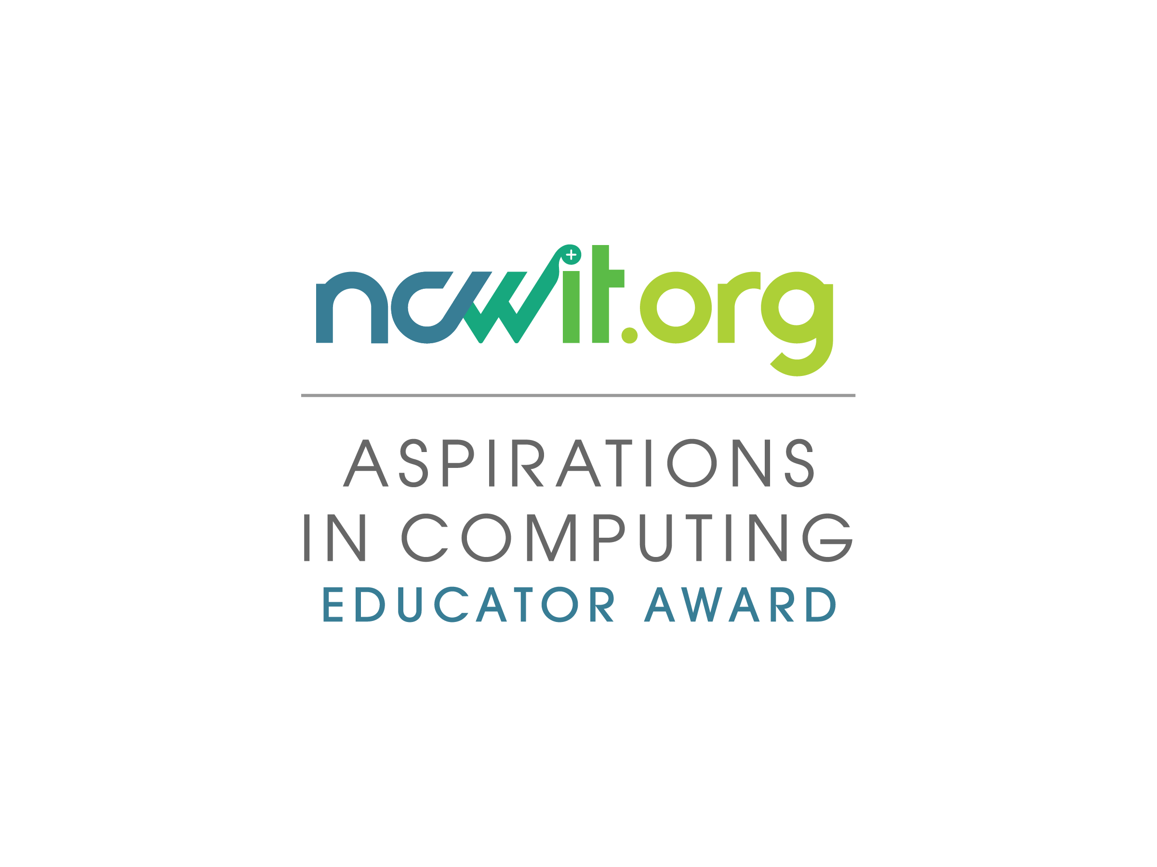

The NCWIT AiC Educator Award identifies exemplary formal and informal educators who play a pivotal role in encouraging 9th-12th grade students who self-identify as women, genderqueer, or non-binary to explore their interest in computing and technology. The award recognizes these educators for their efforts to promote gender equity in computing. Find out more at www.aspirations.org/award-programs/aic-educator-award.

**AiC EDUCATOR AWARD RECIPIENT**



**[NAME]**[School]  
[City/Town]

[Biography… Mr. Nodarse teaches core Computer Science and Technology courses in 6 of the 7 schools which comprise Bergen County Academy since 2001. He has nurtured an interest in his female students in the areas of robotics, engineering, computer programming, and digital electronics. Mr. Nodarse also teaches computer forensics, networking, and computer service and support. He has developed classroom topics which range from the initial handling of computer tools to building a complete computer system which has generated great student interest.

Mr. Nodarse has introduced his students to mobile programming languages, and how digital electronics interphases with other emergent technologies. With supportive mentoring, his female students have participated in the Annual Panasonic Creative Challenge, the Toshiba NSTA ExploraVision Contest, and the Internet Science and Technology Fair. Mr. Nodarse has consistently fostered the working of female and male students together in projects involving technology and engineering thus expanding and reinforcing the student’s concept of the working team.

Mr. Nodarse has a B.S. degree from New Jersey City University. Mr. Nodarse has completed additional accreditation in the CISCO Networking Academy Program (Instructor Training Program), and has certification to teach CISCO: CCNA 1-4, Discovery, Exploration, Java, IT Essentials 1 & 2, Panduit, and Adobe Web Design. Prior to working at Bergen County Academy, Mr. Nodarse worked in the technology industry at Anderson Consulting Firm.]

**NCWIT ASPIRATIONS IN COMPUTING SPONSORS**

**Lifetime Partner**

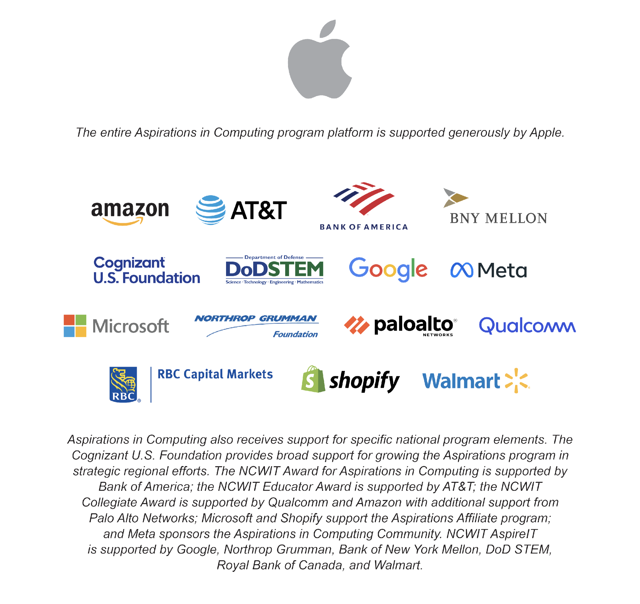



**Strategic Partners**

**Additional Support**

**

**NCWIT [NAME] AFFILIATE AWARD FOR   
ASPIRATIONS IN COMPUTING SPONSORS**

