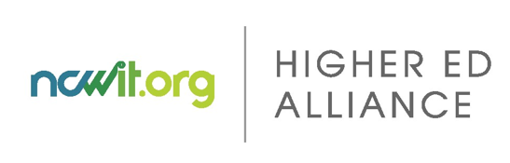
NCWIT Tech Inclusion Journey® for Undergraduate Programs (TIJ-UP)

ACTION PLANNING TEMPLATE
This template is intended for use after your team has completed the TIJ-UP’s Assessment Tool and held Consensus Conversations, and in conjunction with the TIJ-UP Action Planning Guide. Refer to the Plan & Act section of the TIJ-UP tool and NCWIT.org for ideas and information on promising practices for broadening participation in computing. In using this template, you will answer these key questions:

- What focus areas do we want to prioritize to tackle?
- What assets do we have in place that we can leverage?
- What is our timeline for specific goals and initiatives?
- Who is responsible for what?
- How will we know if we are successful?

By working through the entire TIJ-UP process--including completing this template--you’ll end up with an actionable strategic plan for broadening participation in your undergraduate computing program.

Definitions:

TIJ-UP: NCWIT’s Tech Inclusion Journey® is an online tool designed to help undergraduate computing degree programs strategically plan for broadening participation by improving their culture, policies, procedures, and support structures for students.

Focus Area: NCWIT has identified six core areas, depicted in the System Model for Undergraduate Programs (shown on the next page), as key elements of computing degree programs that are necessary to support broadening participation in computing.

Goal: In the language of strategic planning, goals are ideal states that are written to be visionary. What will things look like when we get where we want to go?

Objective: These are your expected outcomes. The best way to write an outcome is to be “SMART”: make it Specific, Measurable, Attainable, Relevant, Time-Based. Evaluation metrics will fall out easily from that.

Initiative: An initiative is a specific project, event, or deliverable that contributes to the achievement of an objective.

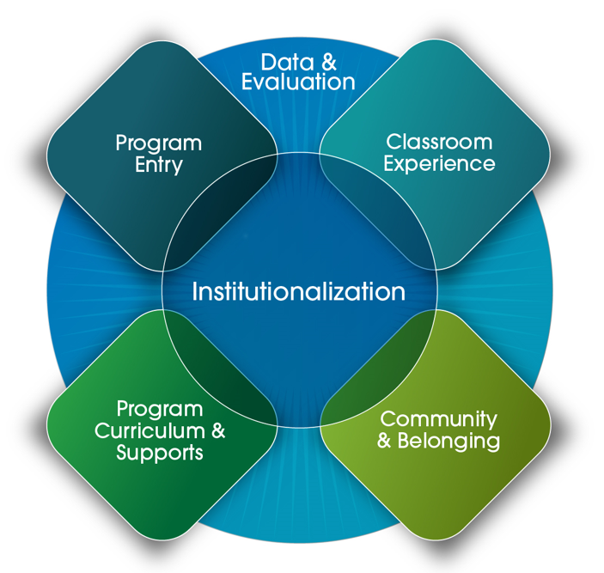
NCWIT’s System Model for Undergraduate Programs
Focus Areas:
- Program Entry
- Classroom Experience
- Community & Belonging
- Program Curriculum & Supports
- Data & Evaluation
- Institutionalization

Plan Example:

FOCUS AREA | Program Entry: The goal of this focus area is to attract and enroll a diverse range of students in your computing program.
GOAL | Attract and enroll more women in our undergraduate CS degree.
To build out multiple objectives with several initiatives, simply copy/paste the following rows for each objective. To add Focus Areas, copy/paste the relevant tables.

OBJECTIVE #1  A measurable outcome needed to reach your ideal state (Specific, Measurable, Attainable, Relevant, Time-Based). | In the fall of 2026, the incoming class of computer science majors will be 30% women. (an objective of this scope would likely require several initiatives)
OBJECTIVE #1 INITIATIVES
Specific projects, events, or deliverables that contribute to the achievement of the objective
INITIATIVE 1.1 NAME | College Recruiter Training
INITIATIVE 1.1 DESCRIPTION | Provide training to college recruiters, who are often the first people from our college to communicate with students. The training will include information about the problem of women’s underrepresentation in computing, strategies about messaging effectively about computing, and accurate and engaging information about computer science as a field and our program in particular.
WHO’S RESPONSIBLE | Project Lead: XXXX Recruiter liaison: XXXX Evaluation: XXXX Other team members: XXXX, XXXX, XXXX
TIMELINE | Fall 2024: team gathers materials and drafts training. Winter 2025: training tested with small groups of recruiters; revised. Spring 2025: two sessions of training with recruiters. Fall 2025: Followup Q&A session with recruiters
OUTCOMES & INDICATORS | Short post-training survey (for recruiters); pulse surveys with recruiters after major recruiting events

ACTION PLANNING TEMPLATE

FOCUS AREA

GOAL

To build out multiple objectives with several initiatives, simply copy/paste the following rows for each objective. To add Focus Areas, copy/paste the relevant tables.

OBJECTIVE #1
A measurable outcome needed to reach your ideal state (Specific, Measurable, Attainable, Relevant, Time-Based).
OBJECTIVE #1 INITIATIVES
Specific projects, events, or deliverables that contribute to the achievement of the objective
INITIATIVE 1.1 NAME
INITIATIVE 1.1 DESCRIPTION
WHO’S RESPONSIBLE
TIMELINE
OUTCOMES & INDICATORS

OBJECTIVE #2
A measurable outcome needed to reach your ideal state (Specific, Measurable, Attainable, Relevant, Time-Based).
OBJECTIVE #2 INITIATIVES
Specific projects, events, or deliverables that contribute to the achievement of the objective
INITIATIVE 2.1 NAME
INITIATIVE 2.1 DESCRIPTION
WHO’S RESPONSIBLE
TIMELINE
OUTCOMES & INDICATORS

